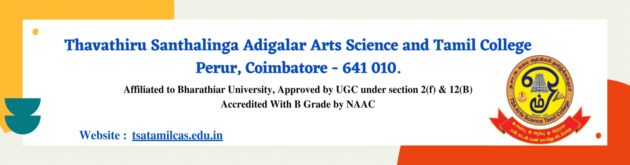

**Criteria VI – GOVERNANCE, LEADERSHIP AND MANAGEMENT**

**6.2 Strategy Development and Deployment**

**6.2.2. The functioning of the institutional bodies is effective and efficient as visible from policies, administrative setup, appointment and service rules, procedures, etc.**



**Organization structure**

**GOVERNING BODY**

**SECRETARY**

**PRINCIPAL**

**PLACEMENT**

**IQAC**

**COMMITTEES**

**NON-TEACHING**

**TEACHING/ HODs**

* **NSS**
* **NCC**
* **DEPARTMENTAL ASSOCIATION**
* **YRC & RRC**
* **RESEARCH**
* **UGC**
* **EXAMINATION CELL**
* **CULTURAL ARTS**
* **WOMEN WELFARE**
* **ANTI RAGGING CURFEW**
* **SEXUAL HARASSMENT & PREVENTION**
* **LIBRARY**
* **STUDENTS’ HANDBOOK**
* **PSYCHOLOGICAL GUIDANCE AND COUNSELLING**
* **SPORTS DEVELOPMEMT**
* **TEACHING AND NON – TEACHING STAFF WELFARE**

**IQAC CO-ORDINATOR**

* **TEACHING FACULTY**
* **TECHNICAL FACULTY**
* **LIBRARAIAN**
* **PHYSICAL DIRCTOR**
* **OFFICE ASSISTANT**
* **TYPIST**
* **RECORD CLERK**
* **PEON**
* **SWEEPER & SCAVENGER**
* **SWEEPER**

**ASSISTANT IQAC CO-ORDINATOR**

**IQAC MEMBERS**

**STUDETNS**